ADLD Course Project
Team-5
Under the guidance of
Dr. Saroja V Siddamal.
Name

USN

Roll no
T. Maitri
01FE20BEC120
304
Sheela Kapase
01Fe20BEC094
244
Statement:
Synchronous FIFO with parameterized
FIFO depth.
Introduction:
Synchronous FIFO:
First In First Out (FIFO) is a very popular and
useful design block for purpose of synchronization and a
handshaking mechanism between the modules.
Depth of FIFO:
The number of slots or rows in FIFO is called the
depth of the FIFO.
Width of FIFO:
The number of bits that can be stored in each
slot or row is called the width of the FIFO.
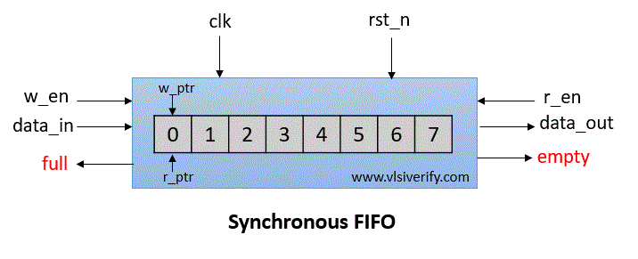
Synchronous FIFO:
In Synchronous FIFO, data read and write operations use the
same clock frequency. Usually, they are used with high clock
frequency to support high-speed systems.
Block Diagram:
Synchronous FIFO operation:
Signals:
wr_en: write enable
wr_data: write data
full: FIFO is full
empty: FIFO is empty
rd_en: read enable
rd_data: read data
w_ptr: write pointer
r_ptr: read pointer
Explanation:
FIFO write operation: FIFO can store/write the wr_data at
every pos edge of the clock based on wr_en signal till it is full.
The write pointer gets incremented on every data write in FIFO
memory.
FIFO read operation: The data can be taken out or read from
FIFO at every pos edge of the clock based on the rd_en signal till
it is empty. The read pointer gets incremented on every data
read from FIFO memory.
Empty condition:
Count == 0 i.e. FIFO contains nothing.
Full condition:

count == FIFO_DEPTH i.e. counter value has reached till
the depth of FIFO
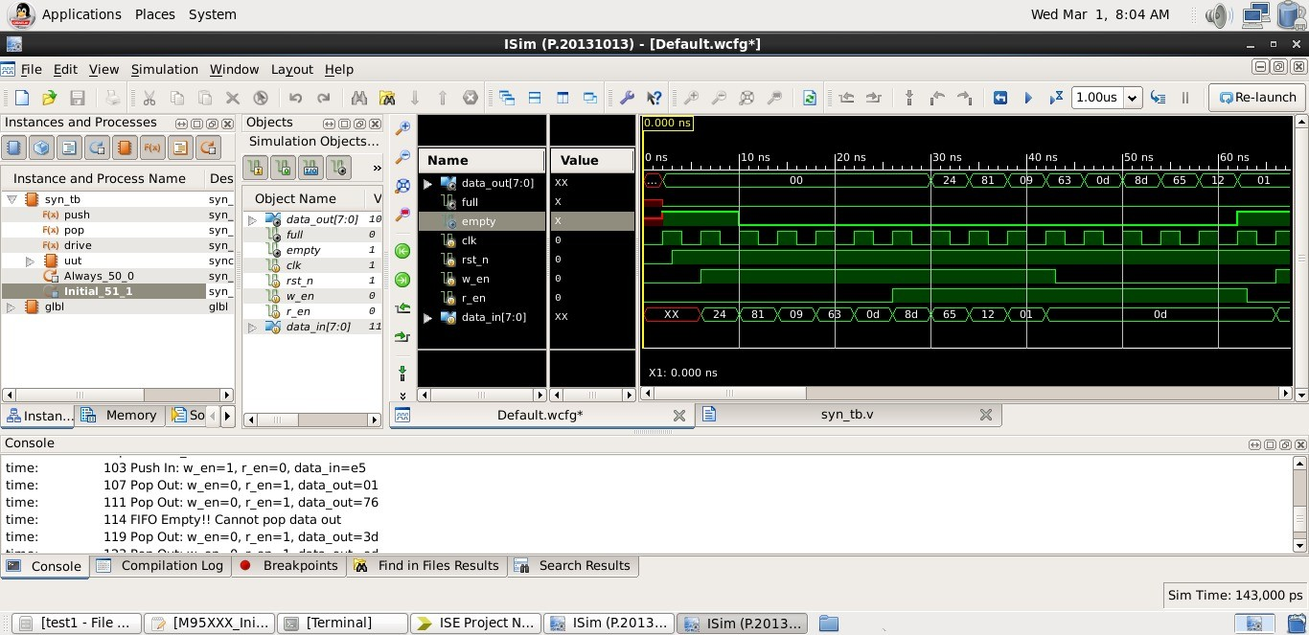
Simulation:
THANK YOU

